Based on: Bitter experience.

**Note:** Sections highlighted in Red are options for this assignment!

# Closing Kit (Template)

## **COVER**

(Insert evocative cover image here)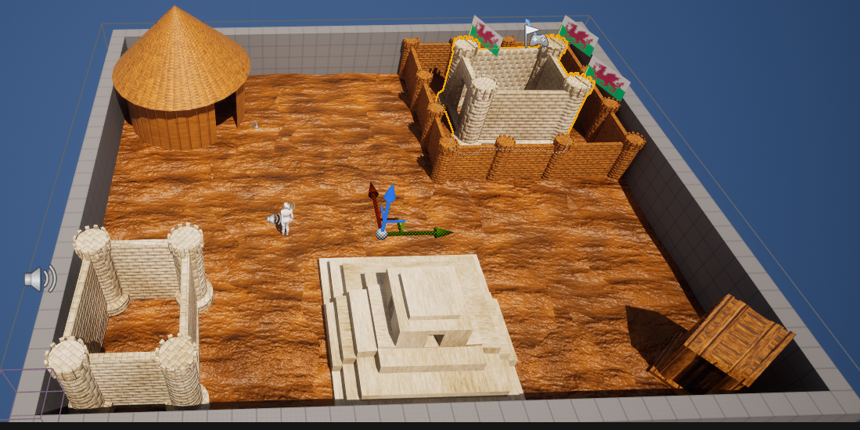

## **YOUR GAME’S TITLE**

Document version number (most recent)

Written by (Ammar Sheraz st20247757)

Point of contact (st20247757@outlook.cardiffmet.ac.uk)

Date of publishing 12/12/2023

Version number (version 1 or unreal 5.2.1).

Footer should always have:

Copyright © st20247757 Date 12/12/2024 Page Number 1 Current Date12/12/2024

**Closing Kit Outline**

**Table of contents**—Remember to keep this current.

Contents

Closing Kit (Template) 1

**COVER** 1

**YOUR GAME’S TITLE** 1

API Versions 3

Release Version 4

Instructions 5

Repository 6

Credits 7

Other IP 8

Issue List 9

# 

# API Versions

For the API versions I used 3ds max 2024 to go about creating my models and assets it was very easy to use as being someone who hasn’t done 3d modelling before I found the application pretty straight forward to use and follow and use , I created my objects / assets in 3ds max and I also used it to create my keyframe animations too. Link to the software here -<https://www.autodesk.co.uk/products/3ds-max/overview?term=1-YEAR&tab=subscription&plc=3DSMAX>

I used photoshop to create the textures and normal maps for my assets. I found making textures easy to on photoshop I was experimenting with the filter tool a lot to make my unique textures and I made some nice textures that I used in my presentation I found photoshop to have a wide range of resources that you could use to make a whole array of different textures. Link to software -<https://www.adobe.com/uk/products/photoshop/pricing-info.html?gclid=CjwKCAiApuCrBhAuEiwA8VJ6Jic2P_5EJ9WETUEM5d6HFNGtc8bYVgWkPrDRPFPKzG-A-b-ydY4TZBoC8t4QAvD_BwE&mv=search&mv2=paidsearch&sdid=DMMD161V&ef_id=CjwKCAiApuCrBhAuEiwA8VJ6Jic2P_5EJ9WETUEM5d6HFNGtc8bYVgWkPrDRPFPKzG-A-b-ydY4TZBoC8t4QAvD_BwE:G:s&s_kwcid=AL!3085!3!432303272530!!!g!458212611005!!9923385541!101895632553&gad_source=1>

The sound effects I made in audition I could of used audacity but it wasn’t working on my computer for some reason so I just went with audition and worked well for me I imported my sounds I made foley sounds so sounds that I recorded by making effects in my room to breathing down the mic to make my breeze sound and editing them down till I was happy with the sound effect but I found audition pretty easy to do for what I needed it to do for my sound effects. Link to software- <https://www.adobe.com/uk/products/audition.html>

# Release Version

**Release Version** — A running version of the game built without debugging information, including the required libraries and assets to run. This might be a release folder or a release build tagged in a VCS.

Link to google drive where you can download zip and play the game -

# Instructions

For the instructions you should be able to launch the game and play I haven’t changed anything in the level I just added my stuff to a game level I haven’t changed anything to do with the camera or added controls because that wasn’t listed in the brief.

To move around you just need left click on the section you want to move to and you move around.

# Repository

Here is a link to the repo-

<https://github.com/amm4rdev/st20247757_assets>

# Credits

I used this as a idea for my final assets idea it was based on this but I added my own twist to it.

Historical and Military Art by Graham Turner - Paintings and Illustrations of Border Reiver Castles (no date) www.studio88.co.uk. Available at: <https://www.studio88.co.uk/acatalog/Strongholds_of_the_Border_Reivers.html> (Accessed: 12 December 2023).

I also used the Wales flag image for my flag texture – 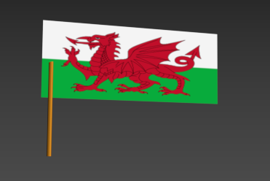

Wikipedia Contributors (2019) Flag of Wales, Wikipedia. Wikimedia Foundation. Available at: <https://en.wikipedia.org/wiki/Flag_of_Wales> .

# 

# Other IP

# Issue List

No issues found all working fine enjoy.